Week 9: Sales and Customer Analytics System
Introduction
The Sales and Customer Analytics System is used to analyze sales transactions, customer purchasing patterns, and product performance. SQL aggregate functions help calculate total sales, average order value, customer spending, and product revenue. These reports help a business understand its performance and make better decisions.

Apply SQL Aggregate Functions
SQL aggregate functions perform calculations on multiple records and return summarized results.
Common aggregate functions:
- COUNT () – Counts the number of records.
- SUM () – Calculates the total value.
- AVG () – Calculates the average value.
- MIN () – Finds the minimum value.
- MAX () – Finds the maximum value.

Generate Total Sales Reports

Total Number of Orders
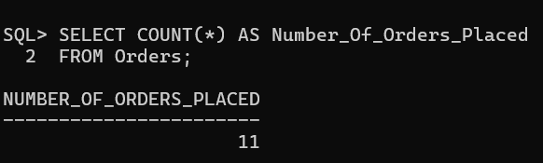
Total Revenue Generated
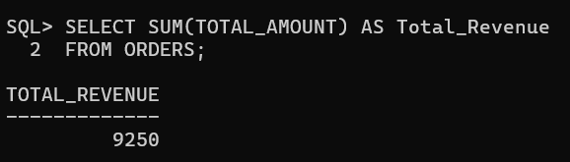
Average Order Value
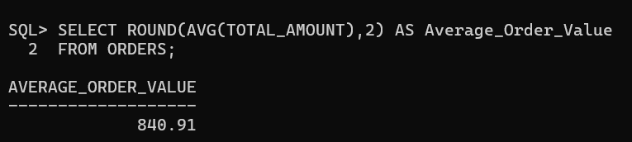
Highest and Lowest Order Amount
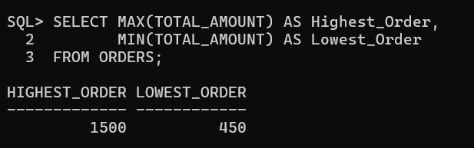
Total Sales for a Specific Period
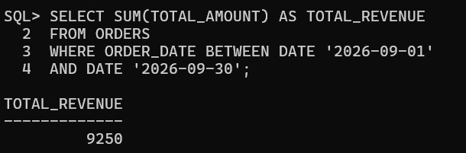
Customer Purchase Analysis
Total Orders Placed by Each Customer
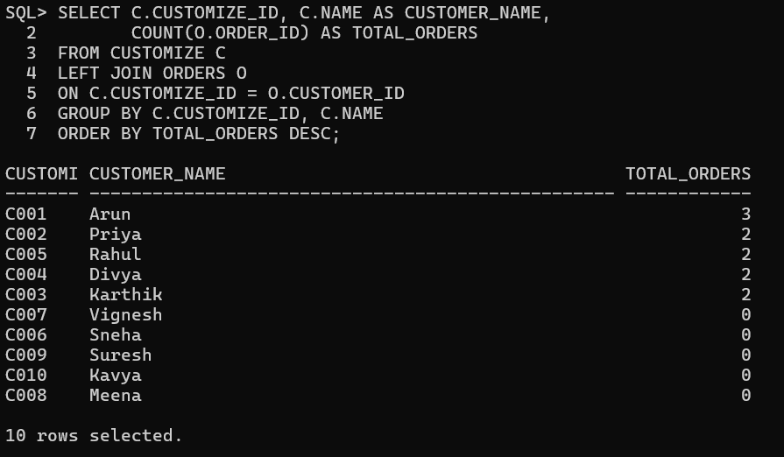
Total Amount Spent by Each Customer
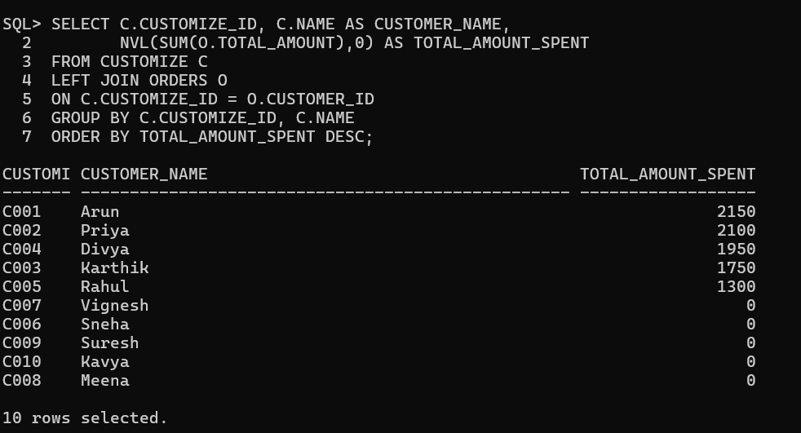
Average Spending per Customer
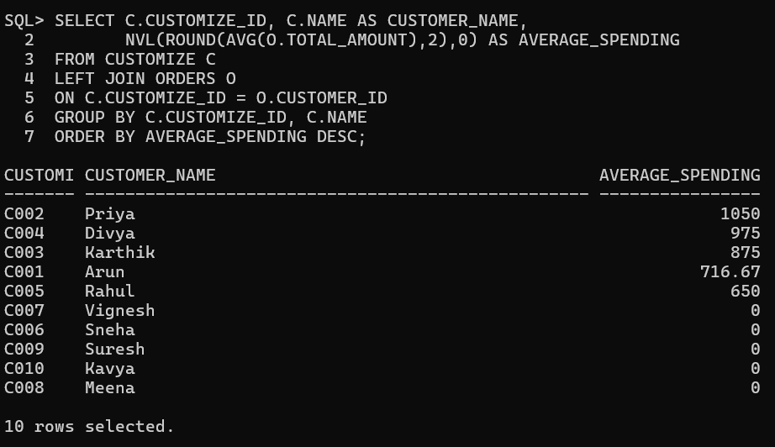
Customer with Maximum Purchase Amount
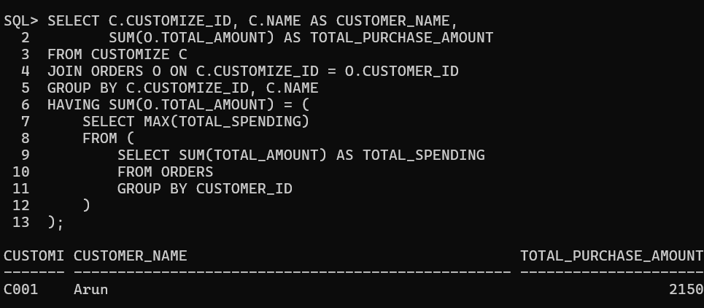

Customers with Fewer Purchases
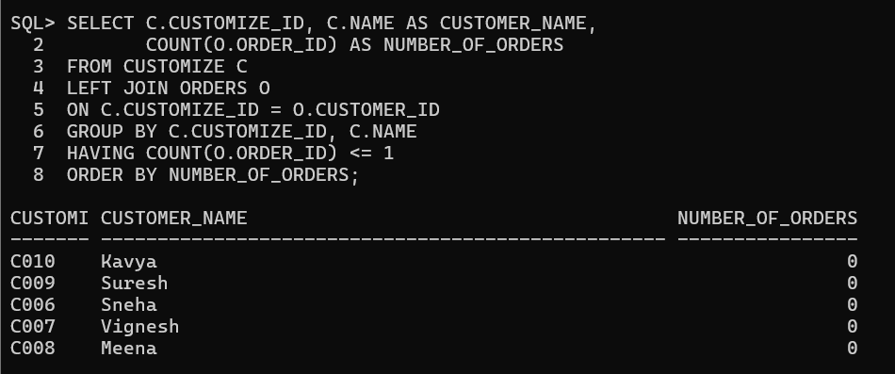
find Top Customers Based on Purchase Amount
Top Five Customers by Total Spending
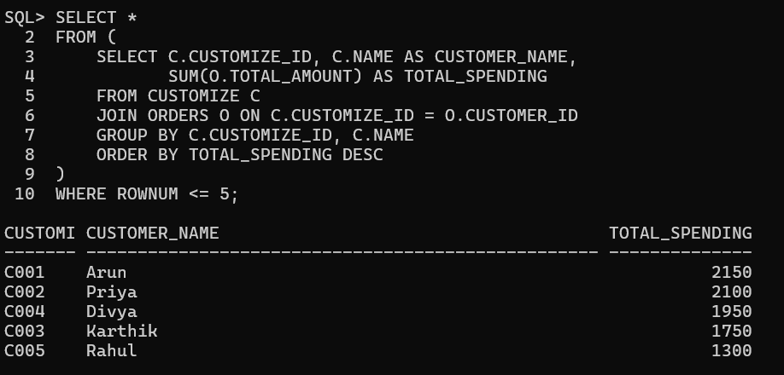
Customers with Maximum Number of Orders
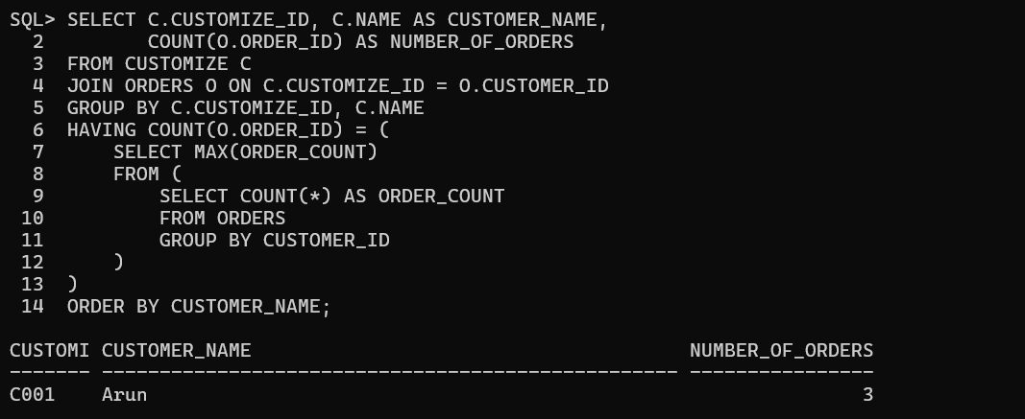

Frequent Customers
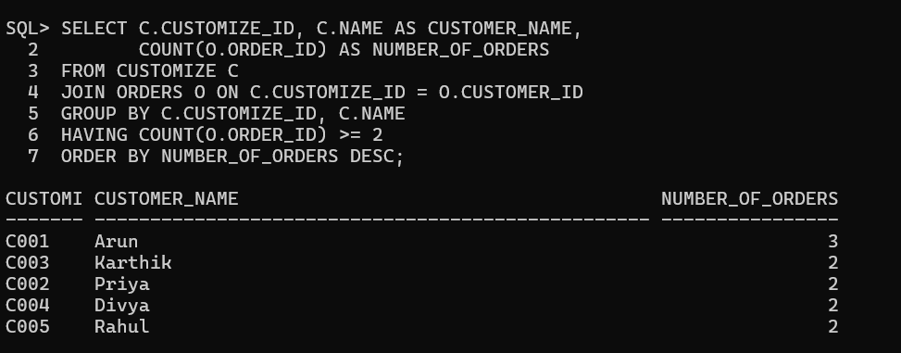
High-Value Customers
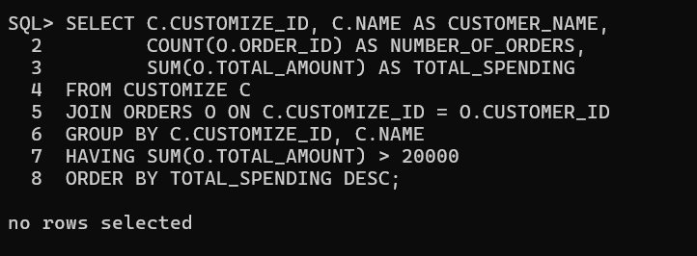
Identify Best-Selling Products
Products with Maximum Sales Quantity

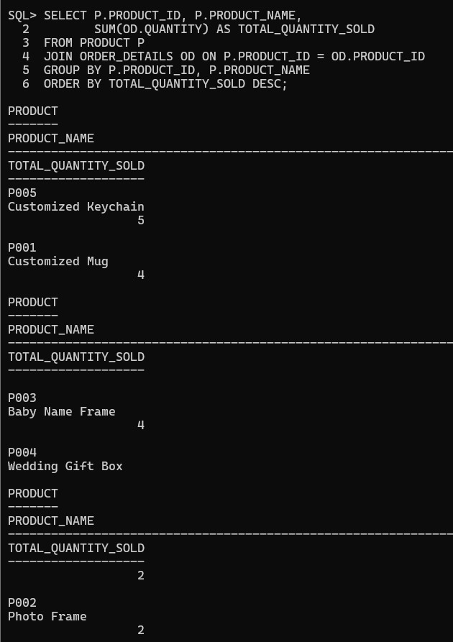

Products Generating Highest Revenue

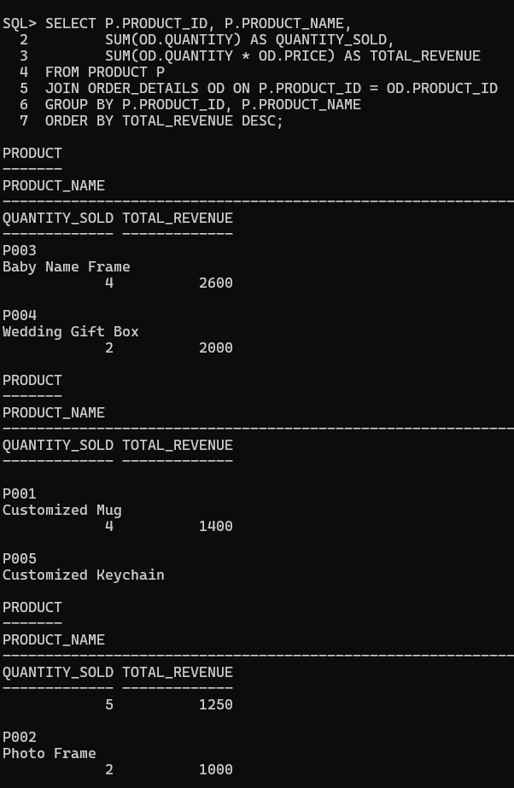

Least-Selling Products

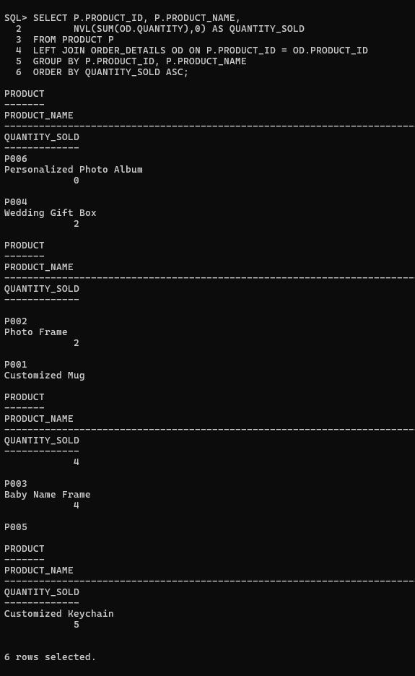
Products Requiring Promotion
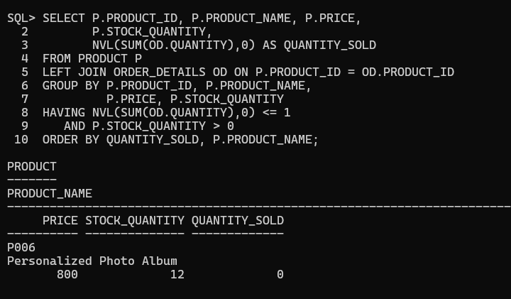

Perform Category-Wise Sales Analysis
Total Sales Generated by Each Category
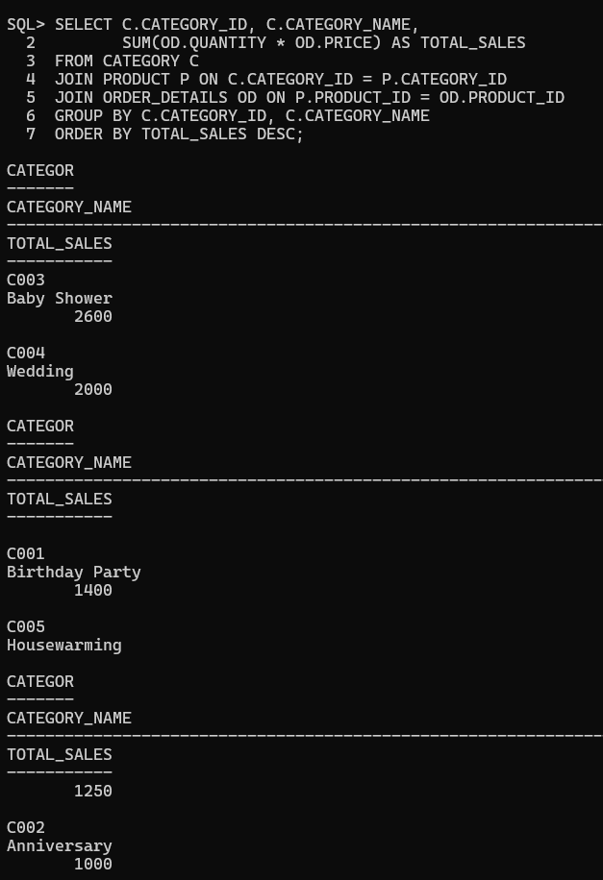
Number of Products Sold in Each Category

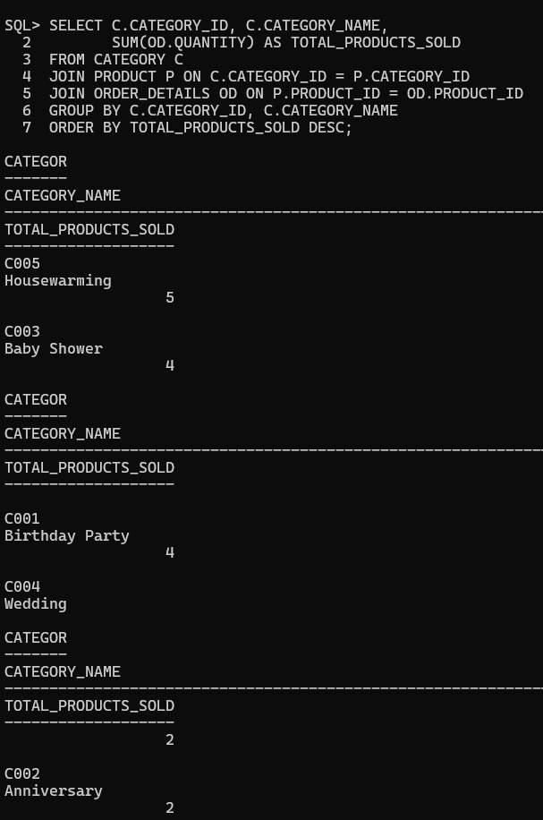
Highest Revenue-Generating Category
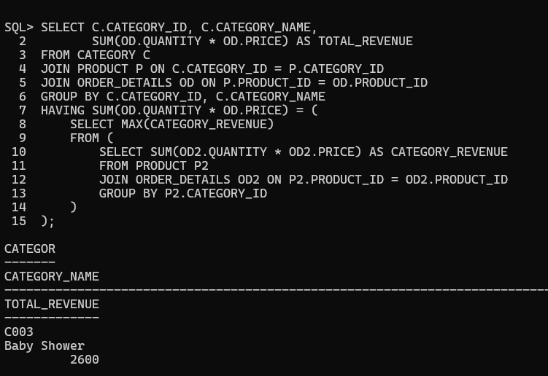

Average Sales per Category
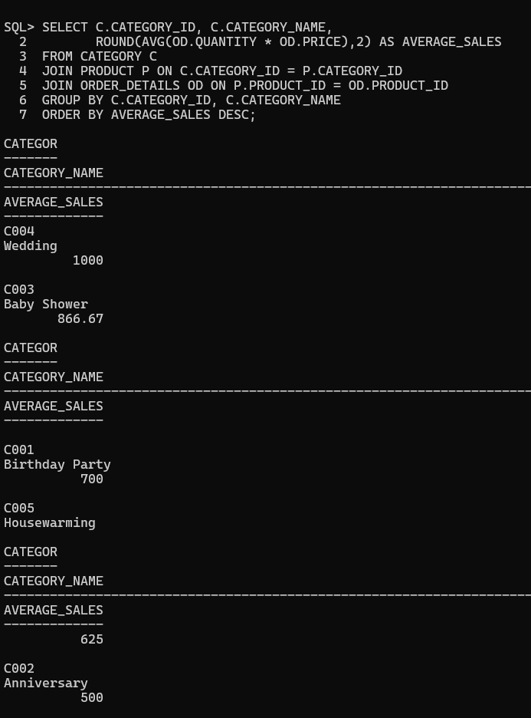
Generate Business Analytics Reports
Sales Performance Report

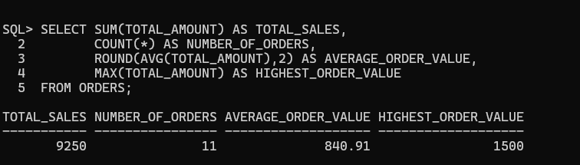

Customer Analytics Report
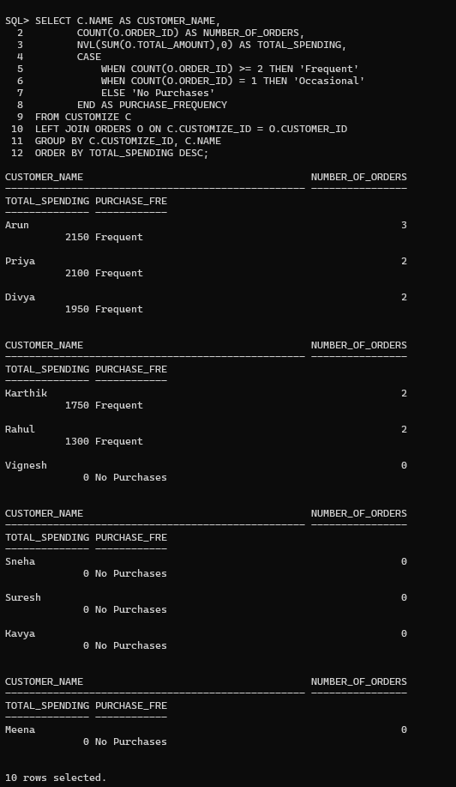

Product Performance Report

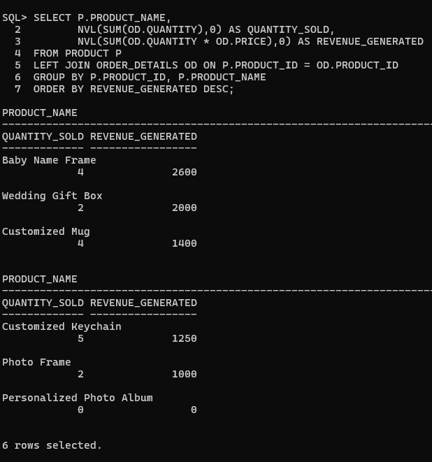
Category Analysis Report
